Project Planning Phase
Project Planning Template (Product Backlog, Sprint Planning, Stories, Story points)

Date | 30 September 2026
Team ID | SWTID-2026-8886
Project Name | Implement Client Script and UI Policy for Incident
Maximum Marks | 5 Marks

Product Backlog, Sprint Schedule, and Estimation (4 Marks)
Use the below template to create product backlog and sprint schedule
Sprint | Functional Requirement (Epic) | User Story Number | User Story / Task | Story Points | Priority | Team Members
Sprint-1 | High impact policy | USN-1 | Require group and assignee when Impact is High | 3 | High | To be completed by team
Sprint-1 | Urgency automation | USN-2 | Set Urgency to High on Impact change | 2 | High | To be completed by team
Sprint-1 | Save validation | USN-3 | Block save and explain missing routing | 3 | High | To be completed by team
Sprint-1 | Discovery | USN-4 | Confirm fields, choice values, and conflicts | 2 | High | To be completed by team
Sprint-2 | List workflow | USN-5 | Decline list State edits in demo | 1 | Medium | To be completed by team
Sprint-2 | UAT | USN-6 | Run positive, negative, reversal, and UI tests | 3 | High | To be completed by team
Sprint-2 | Handoff | USN-7 | Fix, document, review, and plan rollback | 1 | Medium | To be completed by team
Sprint-2 | Extension decision | USN-8 | Decide whether server-side controls are required | 0 | Medium | To be completed by team

Project Tracker, Velocity & Burndown Chart: (4 Marks)
Sprint | Total Story Points | Duration | Sprint Start Date | Sprint End Date (Planned) | Story Points Completed (as on Planned End Date) | Sprint Release Date (Actual)
Sprint-1 | 10 | 5 work days | To be scheduled | To be scheduled | Not run | Not released
Sprint-2 | 5 | 5 work days | To be scheduled | To be scheduled | Not run | Not released

Velocity:
Imagine we have a 10-day sprint duration, and the velocity of the team is 20 (points per sprint). Let’s calculate the team’s average velocity (AV) per iteration unit (story points per day)
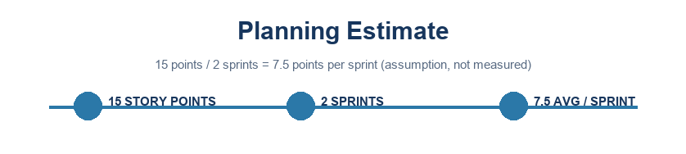

Burndown Chart:
A burn down chart is a graphical representation of work left to do versus time. It is often used in agile software development methodologies such as Scrum. However, burn down charts can be applied to any project containing measurable progress over time.

https://www.visual-paradigm.com/scrum/scrum-burndown-chart/
https://www.atlassian.com/agile/tutorials/burndown-charts

Reference:
https://www.atlassian.com/agile/project-management
https://www.atlassian.com/agile/tutorials/how-to-do-scrum-with-jira-software
https://www.atlassian.com/agile/tutorials/epics
https://www.atlassian.com/agile/tutorials/sprints
https://www.atlassian.com/agile/project-management/estimation
https://www.atlassian.com/agile/tutorials/burndown-charts

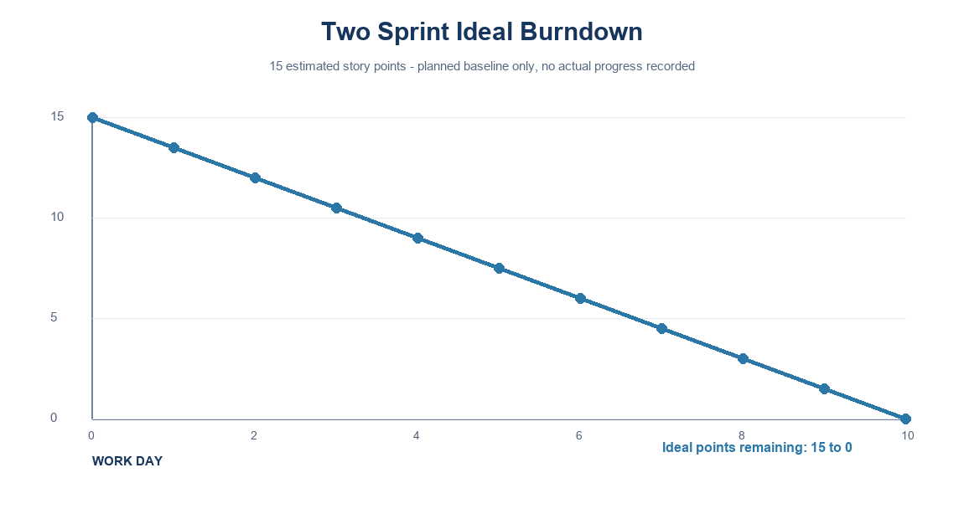
Ideal plan only - no actual progress recorded
Project note: values use the standard Incident choices where Impact 1 and Urgency 1 represent High. Confirm field names and values in the target instance.

